## **User Manual**

1. Type command **start_gui_single_mode** in MATLAB.

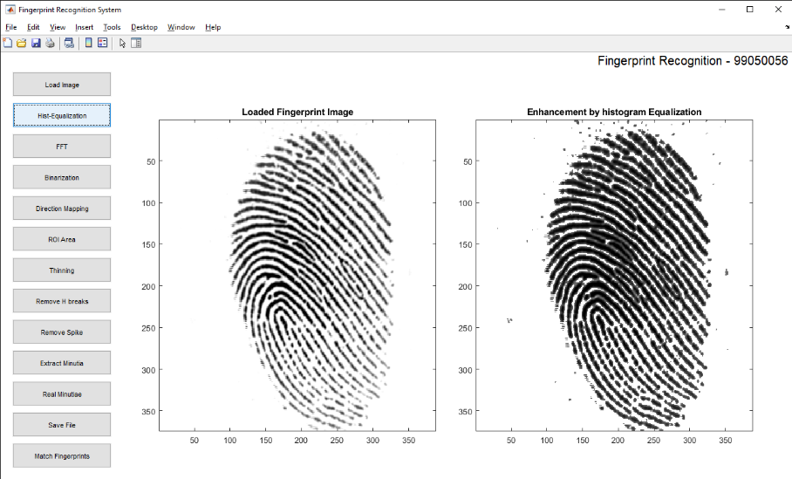

Figure M.1 the User Interface of the Fingerprint Recognition System. The series of buttons on the left side will be invoked sequentially in the consequent demonstration. The two blank areas are used to show the fingerprint image before and after a transaction respectively.

2. Click on the **Load Image** Button

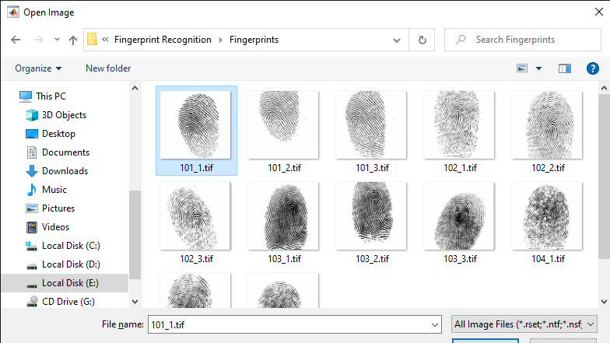

Figure M.2 Load a gray level fingerprint image from a drive specified by Users. Multiple formats are supported and the image size is not limited. But the fingerprint ridges should have large gray intensity comparing with the background and valleys.

3. Click on the **Hist-Equalization** Button

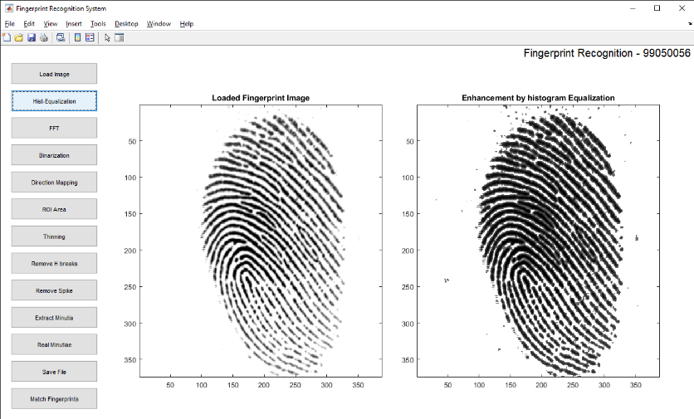

Figure M.3 After Histogram Equalization. The image on the left side is the original fingerprint. The enhanced image after the Histogram Equalization is shown on the right side.

4. Click on the **FFT** Button

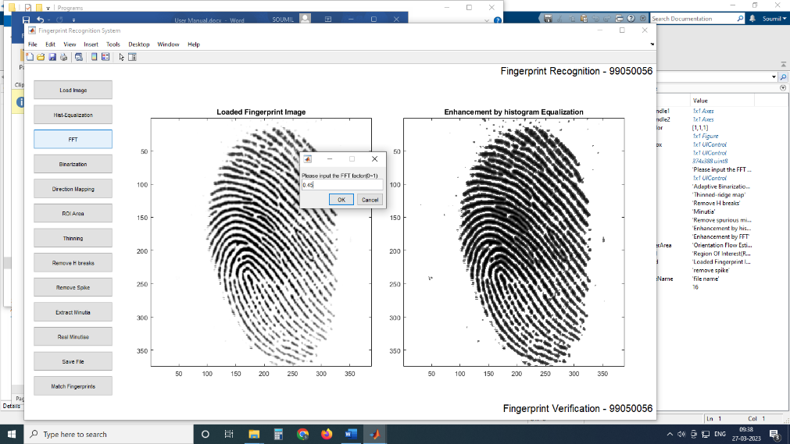

Figure M.4 Captured window after click ‘FFT’ button. The pop-up dialog accepts the parameter k (please refer the formula 2). The experimental optimal k value is 0.45. Users can fill any other constant in the dialog to get a better performance. The enhanced image will be shown in the left screen box, which however is not shown here.

5. Click on the **Binarization** Button

6.Click on the **Direction Mapping** Button

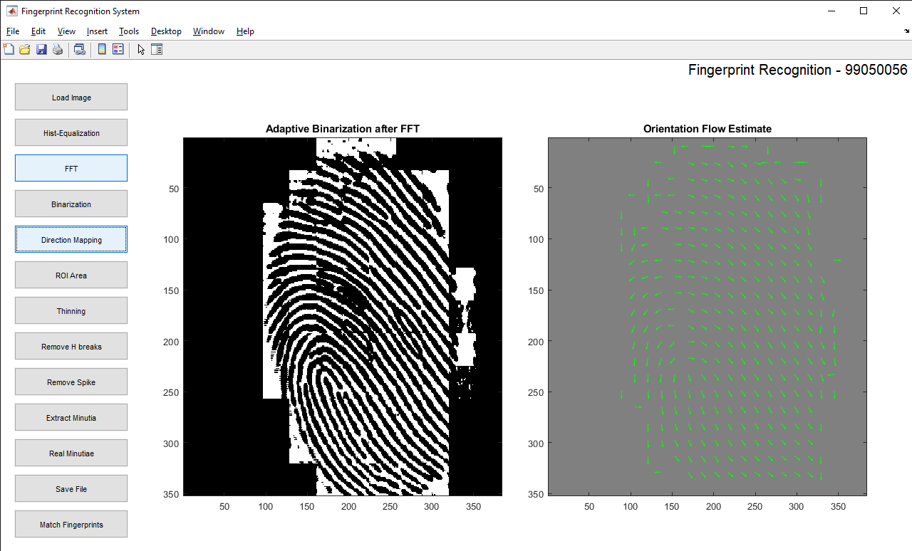

Figure M.5.6 Screen capture after binarization (left) and block direction estimation (right).

7. Click on the **ROI Area** Button

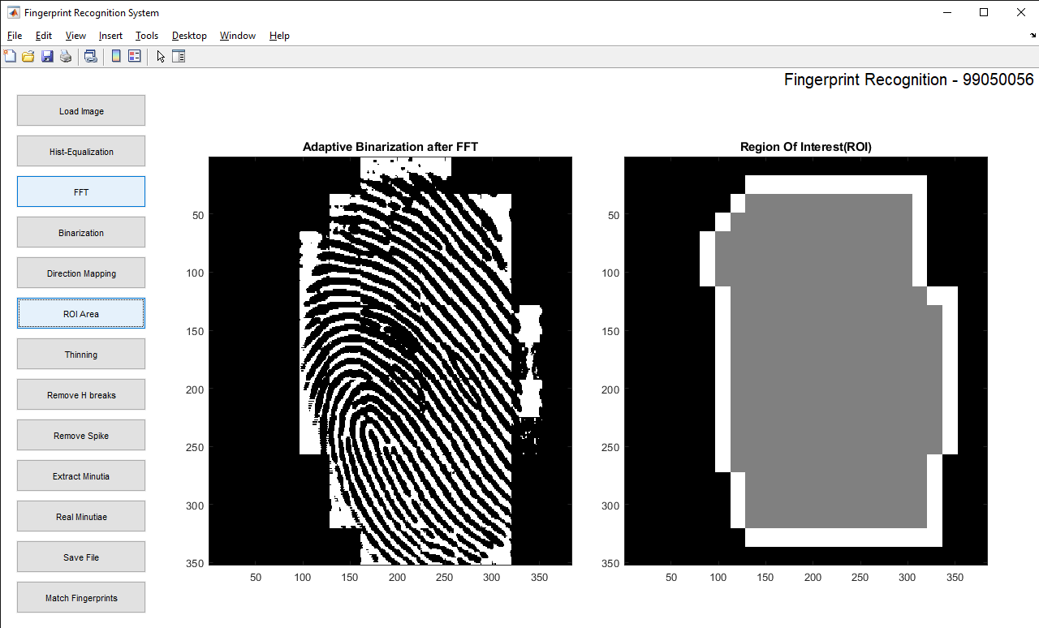

Figure M.7 ROI extraction(right). The intermediate steps for all the morphological operations such close and open are not shown. The right screen box shows the final region of interest of the fingerprint image. The subsequent operations will only operate on the region of interest.

8. Click on the **Thinning** Button

9. Click on the **Remove H breaks** Button

10. Click on the **Remove Spike** Button

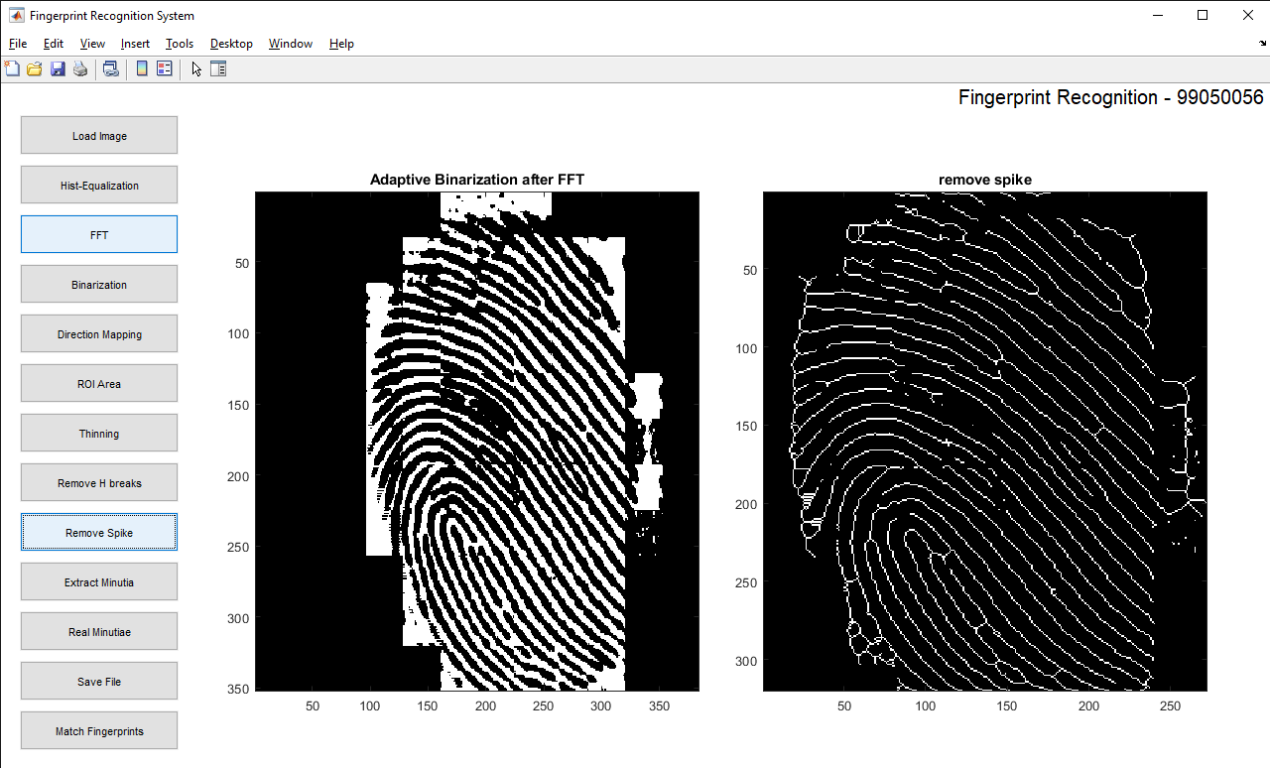

Figure M.10 the Fingerprint image after thining, H breaks removal, isolated peaks removal and spike removal.(right).

1. Click on the **Extract Minutia** Button

12. Click on the **Real Minutiae** Button

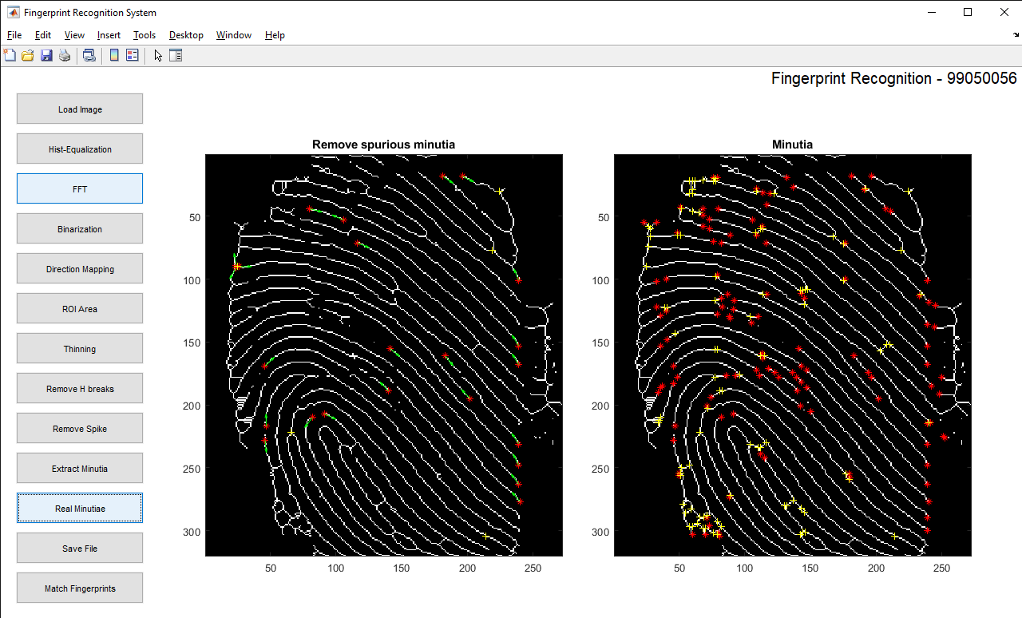

Figure M.12 Minutia Marking (right) and False Minutia Removal (Left). Bifurcations are located with yellow crosses and terminations are denotes with red stars. And the genuine minutia (left) are labeled with orientations with green arrows.

13. Click on the **Save File** Button. Save the file in a .dat file format.

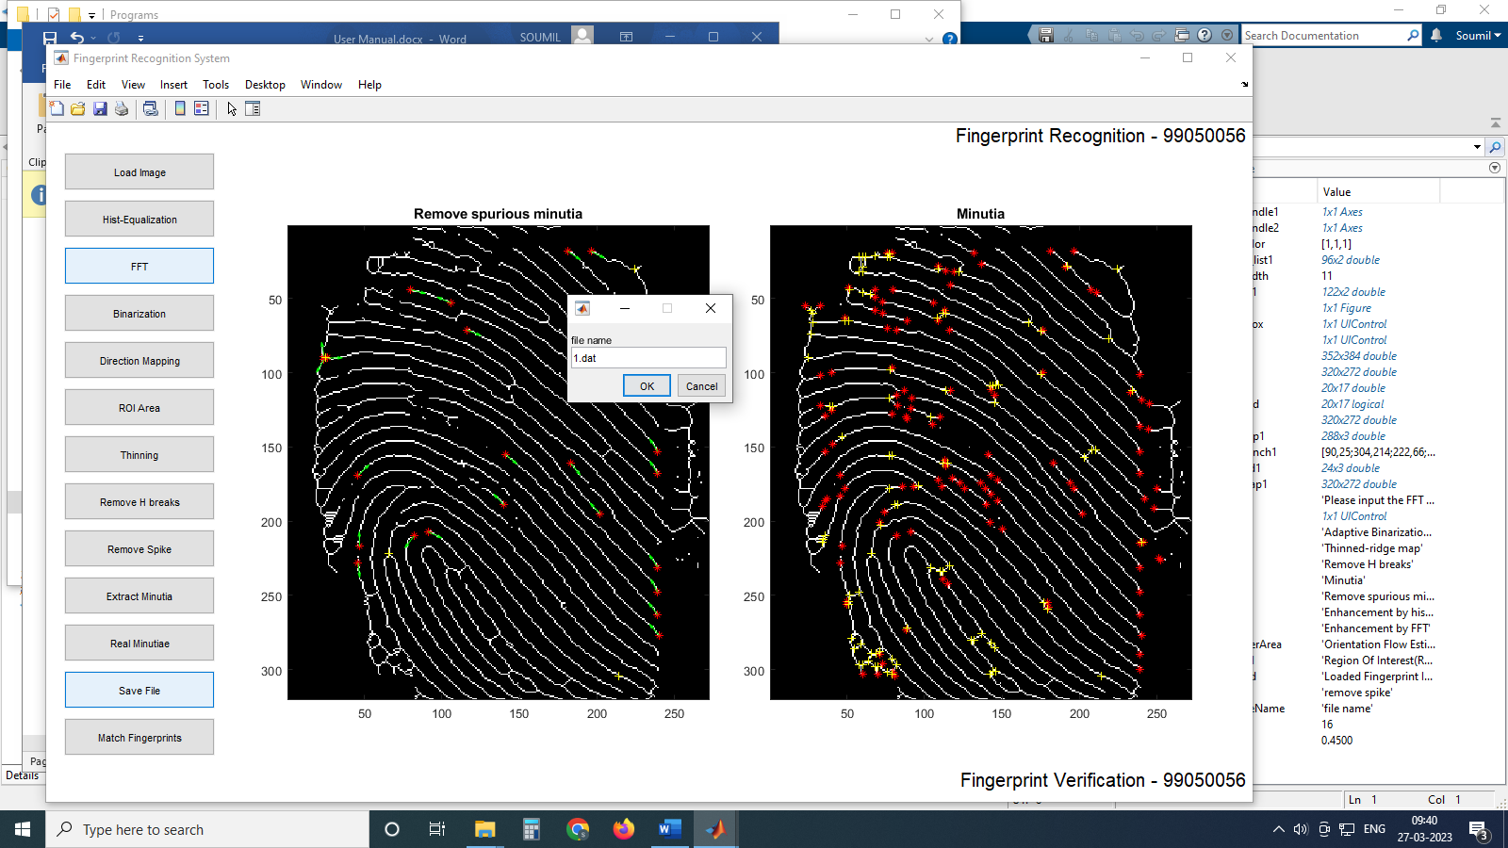

Figure M.13 Save minutia to a .dat file. The saved .dat file stores the information on all genuine minutia. The exact format of the files are explained in the source code.

14. Click on the **Match** Button. Select the 2 files to be matched and wait for the result to be generated.

\

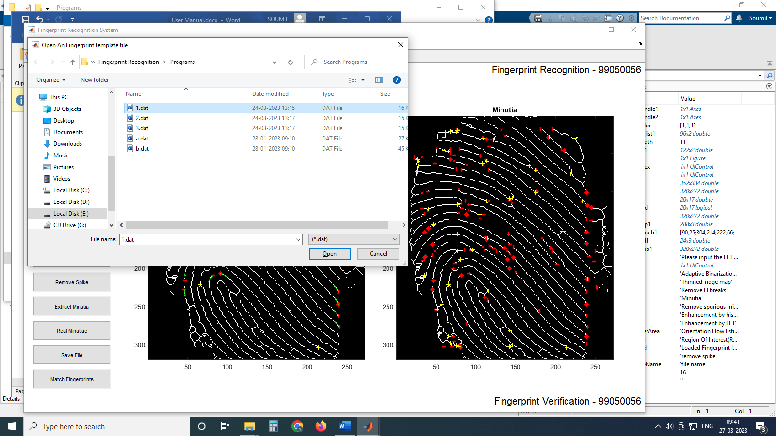

Figure M.14 Load two minutia files and do matching. Users can open two minutia data files from the dialog invoked by clicking the ‘Match’ button. The match algorithm will return a prompt of the match score. But be noted that matching in the GUI mode is not encouraged since the match algorithm relies on heavy computation. Unpredicted states will happen after a long irresponsive running time. Batch testing is prepared for testing match. Please refer the source files for batch testing.